|  |
| --- |
| Circle Language Spec |

## Relations

### Referrers

#### Concept

Objects contain references to other objects. At first, a referenced object is not* aware of its referrers, but* it is also an option for an object to register all its referrers in a list.

The* referrers are not* the* parents containing the* references to the* object, but* the* referrers are the* *references* to the* object themselves.

When* a related item is set to point to a certain object, the* **Related Item . Object . Set** command will update the* target’s list of **Referrers**. So the* *referrers* update the* target’s **Referrers** list. The* referenced object does not* update the* **Referrers** list itself.

The* **Referrers** list consists of references *back* to the* referrers, but* that does *not\** mean the* object in turn becomes a referrer of the* referrer again.

An object can* have a referrers list, but* an object reference, so a related item or related list item (see the* *System Objects* articles), can* also have its own referrers list for references that refer to references.

##### Not* Supporting the* Referrers Concept

An object could* choose not* to support the* **Referrers** concept, if* the* programmer knows, that this object will be referenced so many times, and there is so little interest in knowing all its referrers, that it would* be ridiculous maintain a list.

But* by default, the* **Referrers** concept is always supported.

#### Diagram Notation

The* referrers of an object are simply displayed as a sub-list called **Referrers**, every item of which points back to the* references to the* object:

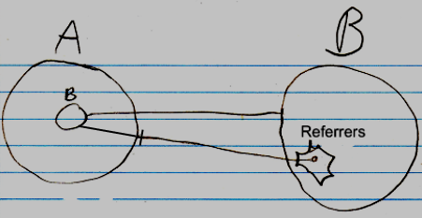

The* entry in the* **Referrers** list is pointing to a related item in the* parent object **A**, not* directly to an object.

The* lines coming out of the* referrers list are usually not* shown, because* a line tied *to* an object already *implies* a referrer. The* diagrams will have more features later, and the* referrer lines would* obscure the* picture.

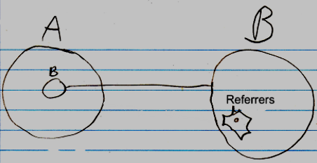

Even the* whole referrers list may even be left out of the* diagram by default, but* it is not* clear yet, if* that is the* way to go.

If* something refers to a reference, then* this may look like this in a diagram:

**b** in **A** is a reference to the* reference to **c** inside **B**. To display the* referrers in the* diagram, you* could* <>do something like this<>:

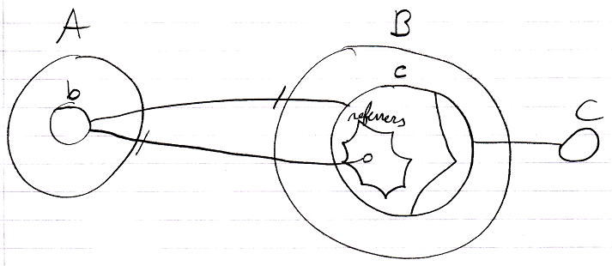

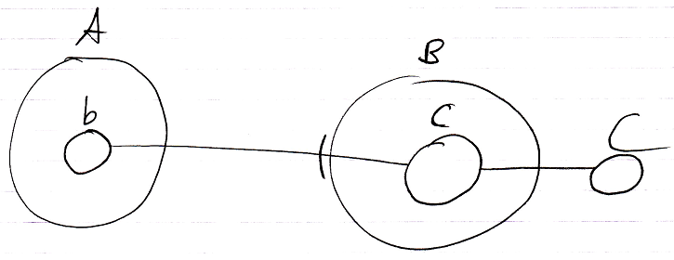

### Class Referrers

#### Concept

The* *Referrers* article explained how an object can* be made aware of its referrers. A *class* can* also be made aware of the* objects using it as a class.

Classes are implemented as an aspect. That concept adds an object reference to the* system interface. This object reference points out which other object is its class. So oddly, an object reference, that points out the* class, is already added to the* class’s list of referrers. The* classes are registered inside the* same list of referrers as object referrers. This is actually just fine. The* **Referrers** list is supposed to be a low-level view on the* referrers.

A class is usually only *used* as a class, and not* also used as an object, so in practice, the* **Referrers** list of a class, actually already *is* a list of class referrers. So a separate list of **Class Referrers** will not* be implemented.

But* if* in the* future there is a need to also maintain a separate list of class referrers, a separate **Class Referrers** concept could* be implemented. In that case, when* a related item’s *class* is set, the* **Related Item . Class . Set** will update the* target’s list of **Class Referrers**.

##### Not* Registering Class Referrers

The* amount of referrers of a **Number** *object* may be small, but* the* amount of referrers of the* **Number** *class* is humungous. The* class will even have a **Referrers** list, when* the* class is not* a created object, because* **Referrers** applies to both symbols and objects.

You* would* want to turn the* **Referrers** concept *off* for the* **Number** class and *on* for **Number** objects. But* the* problem here is, that a class is a blueprint for an object. An object only supports **Referrers**, because* the* *class* supports it.

The* first solution proposed was to simply not* support the* **Referrers** concept for classes that are widely used. But* then* for widely used classes, the* **Referrers** concept never be supported. That is against the* idea of supporting the* **Referrers** concept by default.

If* you* can* not* stop a class from supporting **Referrers** without stopping objects from supporting **Referrers** at the* same time, then* the* **Referrers** concept will not* be widely used anymore.

Therefore, you* are going to have to specify for a symbol or object, that it is a non-practitioner of a concept. Derivation of objects will take over the* specified concept, but* not* the* non-practitioner aspect. Or perhaps instead of calling it non-practitioner, you* could* call it **Objects Support Concept Referrers**, or something.

#### Diagram Notation

< The* notation of a reference to an object reference’s class needs to be determined in the* future. >

Because* the* concept of referrers simply also functions as the* concept of class referrers, it can* be displayed in a diagram the* same way, except, that classes and class references are displayed with dashed lines.

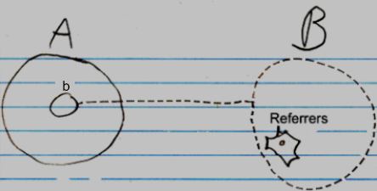

The* reference line of the* item in the* **Referrers** list is displayed, then* it has to point to the* class redirection of symbol **b**. There is no final notation yet for a to something else’s class. But* a preliminary notation could* either be a reference to the* **Class** inside **b**’s system interface:

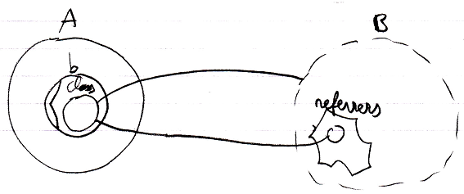

Or a reference line connected to **b**’s class line:

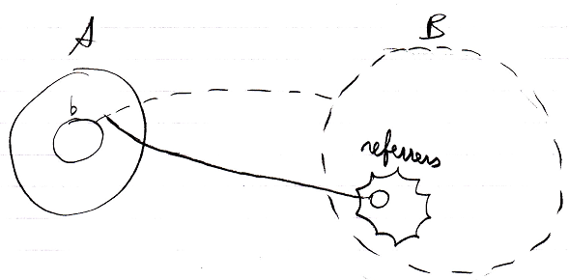

The* referrers are pointed at by solid lines, because* they are just references to the* objects, that use it as a class. No implicit notation of making the* referrer lines *dashed* will be used here, because* that will introduce too much ambiguity in the* diagram notation.

As mentioned in the* article *Referrers*, it is not* clear yet under which circumstances the* whole referrers list might be completely left out of the* diagram.

If* a class defines that its objects support **Referrers**, but* the* class itself won’t register its **Referrers**, then* the* Referrers list of the* class will be drawn out with dashed lines.

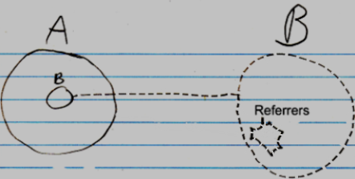

Obviously, the* inactive referrers list will not* contain any object references.

### Related Classes

#### Concept

Target classes specify sub-objects.

If* a sub-object in a class also gets a class assigned to it, then* this relates the* target class to the* target class of the* sub-object. The* target classes of the* sub-objects are called the* object’s *related classes*.

If* a class does not* fix the* class of a related item, then* any type of object could* be assigned as the* related item. If* a class fixes the* class of a related item, then* the* related item can* only become an object of that class.

A class can* also specify related *lists*. If* a class is assigned to this related list, the* related list can* only contain items of this class. If* no class is assigned to a related list, then* the* related list can* contain objects of any class.

A related list can* also be assigned *multiple* classes, meaning that items of a fixed set of classes can* be put inside the* related list.

In that case one related list creates two related classes.

If* a class’s related item does not* have a class, the* related item does not* introduce a new related *class*.

#### Diagram Notation

The* concept of related classes is explained in the* article *Related Classes*. This article only explains its expression in a diagram.

Below are displayed an object and its class. The* class has two sub objects, each of which points to another class:

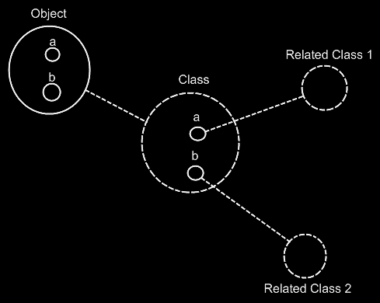

The* **Object** automatically gets the* same contents as the* **Class**. The* object’s sub-objects **a** and **b** could* have been tied to **Related Class 1** and **Related Class 2**, but* they are not*, because* the* sub-objects of **Object** and the* sub-objects of **Class** are implicitly tied together by the* tie between their parents **Object** and **Class** and the* fact, that they have the* same name, following the* principle of *implicitly connected through parent* (will be explained in the* article *Automatic Containment*).

For a big part it is true, that dashes uncover the* structure of a system, while the* solid lines uncover the* system’s data. All the* classes and their related classes and the* lines between them are dashed. However, the* sub-objects defined inside a class are not* dashed, because* they do not* function as classes themselves. And also, the* lines from object to their class are dashed. So it is not* 100% true, that all the* structure elements of the* system are dashed, and all the* data is drawn with a solid line, but* it’s close to it.

When* you* want to see the* structure of the* system, and ignore the* data of the* system, you* just have to look at the* diagram from the* following perspective: class structure = classes tied together.

The* below is the* same example, but* now the* classes get further redirected.

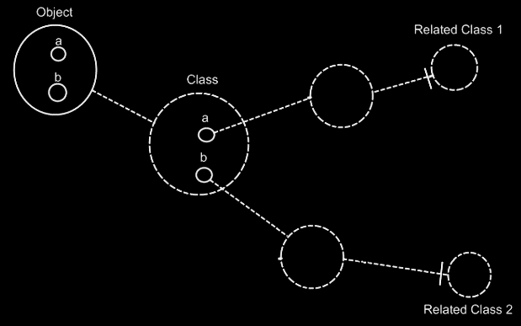

If* the* dashed lines do not* emphasize the* classes and relations enough, a coloring could* be applied to the* diagram, highlighting all the* classes and their relations to other classes.

A class can* also have a related list: a class holds a list of items of another class. A multiplicity of *many* is expressed in the* diagram with a nonagon:



If* the* nonagon is placed inside a class, then* the* class specifies a list of items:

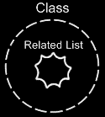

No class is assigned to the* related list here, so the* related list can* contain objects of any class. If* a class is assigned to this related list, the* related list can* only contain items of this class.

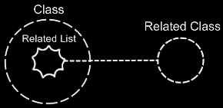

A related list can* also be assigned *multiple* classes, meaning that items of a fixed set of classes can* be put inside the* related list.

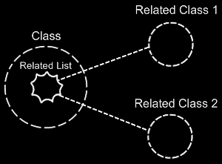

In that case one related list defines two related classes.

If* a class’s related item does not* have a class, the* class has a related item, that can* be od any arbitrary class. So this related *item* does not* introduce a new related *class*.

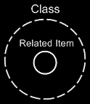

### Relations

#### Concept

One object c an* relate to other objects, but* that’s not* what we are usually speaking of when* we talk about relations. When* we talk about relations, we are talking about relations between *classes*. Relations between classes set the* configuration of how objects can* be connected to eachother. Classes and their relations determine the* rules by which the* objects behave.

The* concept of *relations* is about thinking in relations between classes, rather than loosely tying together arbitrary objects.

A class functions as a blueprint for objects. The* class structure determines which types of objects can* be connected to each other, but* not* yet what specific objects are connected to eachother. Which specific objects are connected to eachother is determined by the* object structure. The* class structure only defines which types of objects can* be connected to eachother.

The* class-relation structure is the* bonestructure of a program.

The* article *Related Classes* already explained how one class relates to other classes. But* this is a very single-sided view on relations. It does not* create a relation from the* related class back to the* first class again.

Relations are usually bi-directional. If* one class relates to another, then* the* other class relates back to the* first class. So next to one class getting a sub-object of another class, the* other class also has to get a sub-object that points back to the* first class.

You* can* also have a **1 🡪 n** relation between two classes. In that case one class has a related list of items of another class. The* other class has a single related item, that connects back to the* first class. There are also **n 🡪 n** relations, where one class holds a related list of items of another class, and the* other class also holds a list of related items, that connects back to the* first class.

#### Diagram Notation

It must be mentioned, that the* method of *automatic containment* applies to unary references, and just *does not* match* yet with the* notation for relations. In the* future it must be further worked out how to best turn them into a single notation.

As explained in the* article *Related Classes in a Diagram*, a relation

between one class and another can* look like this:

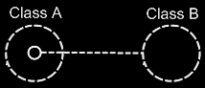

Because* Class A has a sub-object of **Class B**, this creates a relation from **Class A** to **Class B**. However, **Class B** does not* have a relation back to **Class A** yet. The* picture below, adds the* relation back to **Class A**:

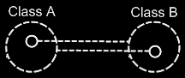

Because* the* class references back and forth are so closely related, the* two class lines merge together to form the* picture below:

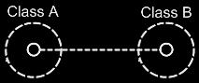

This, however, creates an ambiguity in the* notation. The* two circles tied together with a class line suggest, that they are both the* same class. But* the* circle inside **Class A** represents **Class B** and the* circle inside **Class B** represents **Class A**.

Fortunately, the* notation can* be disambiguated using the* rules of automatic containment. Automatic containment is explained in the* article *Automatic Containment*. Before explaining how automatic containment leads to the* eventual notation, here is the* disambiguated notation of a relation between two classes:

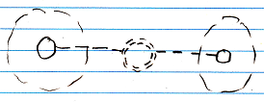

The* notation is accomplished by first taking the* original picture with one class refering to another and the* other refering back to the* first class:



Then*, an imaginary reference to each class is added to the* diagram

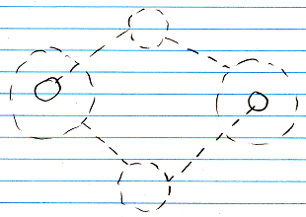

Next, the* class lines are merged, but* also the* class symbols are merged:



The* notation would* still be ambiguous, if* it weren’t for the* double dashed line of the* merged class symbols. So a double dashed circle symbolizes a relation between classes.

The* picture above expresses a 1 🡪 1 relation between **Class A** and **Class B**. But* other multiplicities can* also be used. The* multiplicity of **n** is expressed with a nonagon:



A nonagon represents a list of things. Instead of letting a **Class A** contain a single item of **Class B**, you* can* let is contain a list of items of **Class B**:

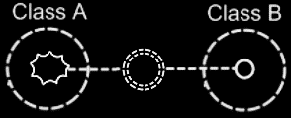

The* picture above expresses an **n 🡪 1** relation between **Class A** and **Class B**.

The* picture below displays a **1 🡪 n** relation between **Class A** and **Class B**.

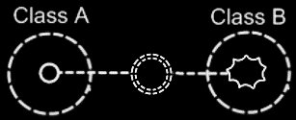

Finally, the* picture below displays an **n 🡪 n** relation between **Class A** and **Class B**.

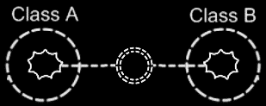

A symbol merge in a relation that has nonagons in it also results in a double dashed circle, because* the* imaginary reference to the* classes, that are put on a higher level, are represented by circles, not* a nonagons.

One related list can* also contain items from multiple classes. **Class A** has a **n 🡪 1** relation to items of **Class B** and **Class C**, it is expressed as follows:

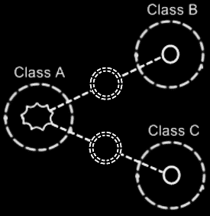

#### Class relating to itself

A class can* have a relation to itself. For instance, a person can* relate to a parent, which is also a person. So a person is related to a person, which relates a class to itself.

A class relating to itself looks as follows in a diagram:



#### Counterpart out of sight

When* the* counterpart of the* relation is out of sight, a line should point out of the* diagram. A catch there is, that you* can*’t see if* the* relation counterpart is part of a multiplicity of **n** or not*. Therefore, the* multiplicity is expressed at the* end of th line pointing out of the* diagram as follows:

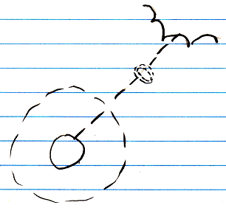

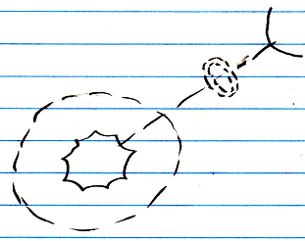

#### No reuse of merged imaginary references

If* two imaginary references have merged, to become a relation symbol, then* other references to the* same classes won’t connect to an imaginary reference that has merged to become a relation symbol. Relations create their own imaginary references, that aren’t reused. This is displayed in the* article *Relations Between Objects in a Diagram*, but* may also apply to the* notation of relations between classes.

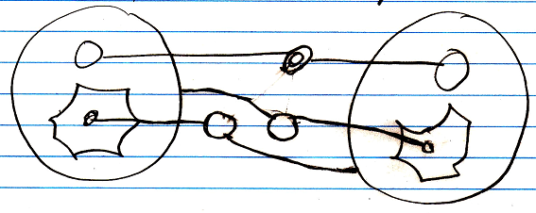

#### Example

Classes and their relations define the* behavior of your system, so it is very important to be aware of them, instead of just looking at individual objects, tied to other objects.

The* example below is part of the* class-relation structure of a drawing program.

It displays the* classes **Application**, **Document**, **Point** and **Line**.

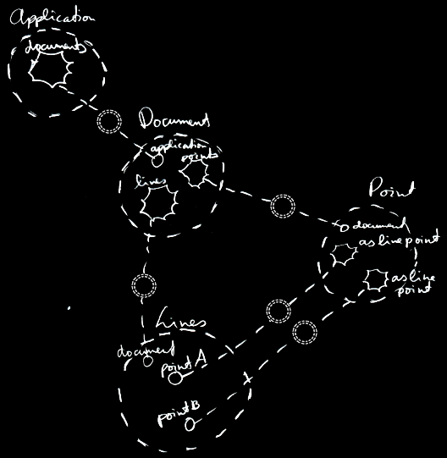

An instance of the* application can* hold multiple open documents. So **Application** has a **1 🡪 n** relation with **Document**. That automatically makes a document part of one instance of the* application. A document holds a collection of points and a collection of lines. That makes **Document** have a **1 🡪 n** relation with **Point** and a **1 🡪 n** relation with **Line**. This automatically makes **Points** and **Lines** part of a single document. Furthermore, a line is composed of two points. However, if* you* chain lines together, a point can* become a part of multiple lines. This gives **Line** two **1 🡪 n** relations with a **Point**: one for the* first point and one for the* second point.

The* example displays all the* classes, relations, related items and related lists of the* object structure.

If* just the* use of dashed lines does not* emphasize the* classes and relations enough, a coloring could* be applied to the* diagram, highlighting all the* classes and relations.

### Dual & Unary

#### Concept

A unary relation is a relation with only one direction: one class relates to another class, but* the* other class doesn’t relate back to the* first class.

A dual relation is a bi-directional relation: one class relates to another class, and the* other class relates back to the* first class.

In most cases, it is best to make a relation dual. You* don’t even have to give the* the* backward related item a name, just let it sit there, until you* find a name for it.

Bi-directional relations were already introduced by the* article *Relations*. What is left to cover is the* reason why to make a relation dual or unary.

#### Ridiculous to maintain backward relation

Only if* storage of a relation counterpart results in a ridiculous amount of data, that you* don't even use, then* you* may want to omit the* backward relation.

This is the* case when* the* target class of the* relation is very generally used. The* key example for this is a **Number**. A number is used by too many other classes, so it is ridiculous to give a **Number** a related list for every class that uses **Numbers**. To determine if* a backward relation is ridiculous to maintain you* could* also consider the* following:

- No functional correspondence with anything particular

- Too many objects will refer to this.

This is all very subjective, but* I can*’t give a more exact definition for it.

#### Unable to program class

Another reason for not* keeping the* backward relation, is that you* may not* be able to program the* target class, because* somebody else authored it. But* there’s a way to go around this: use inheritance to create a derived class, relate to the* derived class, storing the* backward relations inside the* derived class. Then* the* original class is not* burdened with extra related lists. The* derived class is an extension of the* original class.

#### The* Referrers Concept

A **Number** class could* choose to support the* **Referrers** concept. This will give a **Number** object only one list of all referrers, instead of a separate list for every class that uses **Numbers**. **Numbers** may be used by many classes, but* an individual **Number** object, is never used much. It is not* a lot of data to register inside an **Number** object, which objects refer to that particular **Number**.

But* then* the* **Number** class will also register all its *class referrers*, which is undoable, because* a humungous amount of objects refer to this class. But* a solution for this was already proposed by the* article *Class Referrers*. You* can* choose for a class to not* register its class referrers, while objects do register their referrers.

#### No exact formula

I admit, that I would* like to give an exact formula for when* a backward relation should or should not* be maintained. But* for now, I can* only give a functional description of when* it is ridiculous to maintain a backward relation. A programmer is going to have to determine it, when* a relation should be unary.

#### Diagram Notation

The* concept of dual and unary is explained in the* articles *Dual & Unary, Related Classes* and *Relations*.

The* expression of dual and unary in a diagram has already been introduced in the* articles *Related Classes in a Diagram* and *Relations in a Diagram*. This article only puts the* diagram expressions of dual and unary next eachother for a comparison.

This is a unary relation between **Class A** and **Class B**:

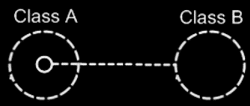

This is a dual relation between **Class A** and **Class B**:

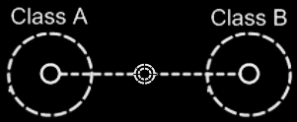

### Relations Between Objects

#### Concept

Relations between classes set the* rules for how objects can* be connected to eachother.

Relations between *objects* are the* actual connections.

A relation between objects is always a relation between *two* individual objects. If* one object refers to another, the* other refers back to the* first one.

From a 1 🡪 1 perspective this seems logical, but* from an n 🡪 n perspective this may not* seem logical.

A relation between two classes with each a multiplicity of **n**, creates a related list in both of the* classes. Every object of those classes will contain a related list of related items.

Any object that as a relation to another object, gives the* other object *one* relation back to the* first object. So for each reference to an object, the* other object contains a reference back. One reference inside an object is tied to one reference inside another object.

One object can* relate to multiple objects, so an object *can\** have a one-to-many relation to other objects, but* one *related item* in one object always creates *one related item* inside the* other object.

#### Diagram Notation

The* main rule about relations to object is: for each reference to an object, the* other object contains a reference back.

When* you* draw out the* separate counterparts of a relation between two objects it looks like this:

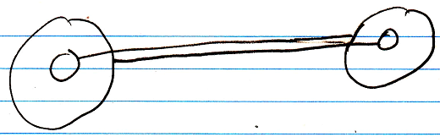

But* to express the* close relation between the* two references, the* two lines are merged, and disambiguated from normal object lines with a *relation symbol*:

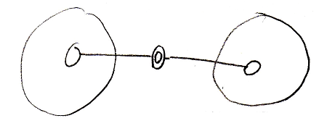

The* relation symbol is a double circle. The* reason behind this notation, was already explained in the* article *Relations in a Diagram*. The* notation is accomplished by first taking the* original picture with one class refering to another and the* other refering back to the* first class:



Then*, an imaginary reference to each class is added to the* diagram

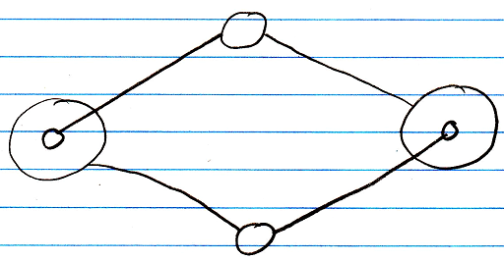

Next, the* class lines are merged, but* also the* class symbols are merged:



The* notation would* still be ambiguous, if* it weren’t for the* double line of the* merged object symbols. So a double circle symbolizes a relation between objects.

For relations between classes the* relation symbol is a double *dashed* circle. For relations between objects, the* relation symbol is a double circle drawn with *solid* lines.

In 1 🡪 n and n 🡪 n relations the* rule, that each reference contains one reference back, also applies:

1 🡪 n:

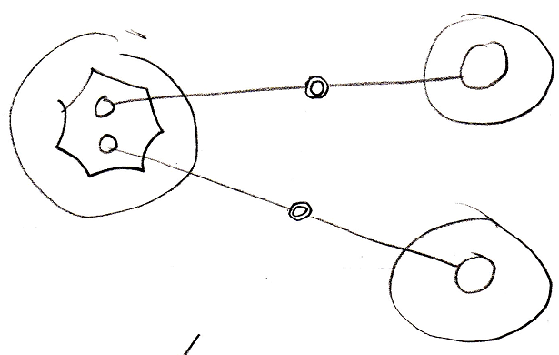

n 🡪 n:

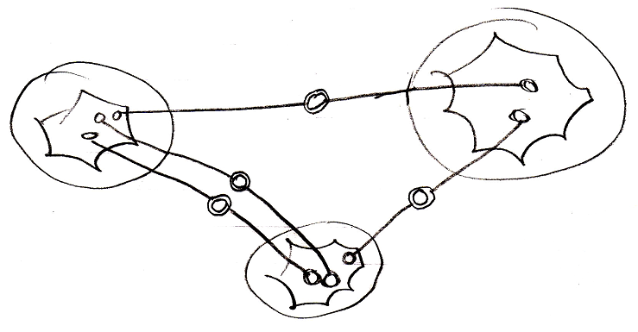

It doesn’t matter whether an object reference is part of a list or not*: every time it is still *two* individual object references, that are tied together.

#### Object relating to itself

Sometimes an object relates to itself. In a diagram this looks as follows:

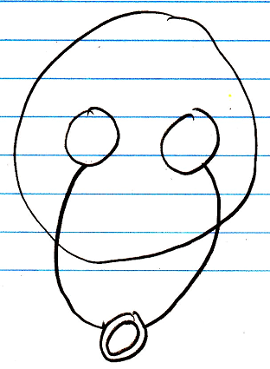

#### Counterpart out of sight

When* the* counterpart of the* relation is out of sight, a line should point out of the* diagram. A catch there is, that you* can*’t see if* the* relation counterpart is part of a multiplicity of **n** or not*. Therefore, the* multiplicity is expressed at the* end of th line pointing out of the* diagram as follows:

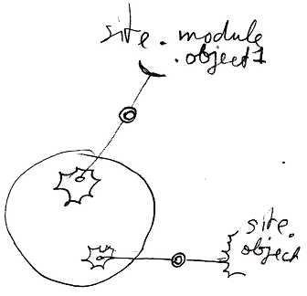

#### No reuse of merged imaginary references

If* two imaginary references have merged, to become a relation symbol, then* other references to the* same objects won’t connect to an imaginary reference that has merged to become a relation symbol. Relations create their own imaginary references, that aren’t reused.

Here is a relation between two objects:



The* two objects refer to eachother. This originally consisted of two distinct references:



Imaginary references were put on one level higher:



If* other references to the* same objects were also displayed in the* diagram, then* they would* connect to the* same imaginary references, put on a higher level:

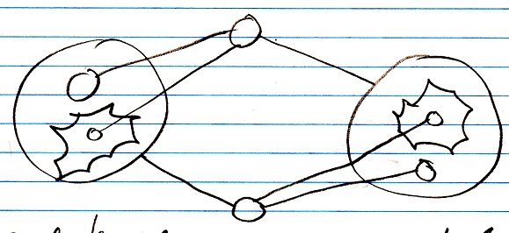

When* you* merge the* imaginary references to display that two references are part of a single relation, you* will not* connect all

references to the* merged imaginary reference:

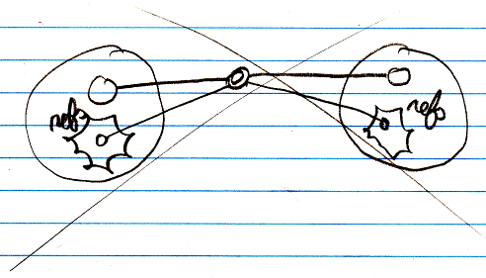

You* will keep separate imaginary references for the* other unary relations to the* objects:



### Referrers Versus Related Objects

Referrers are handy, when* so many classes relate to another class, that the* other class does not* want to maintain a separate list for each class that links to it.

It is also handy for when* a class can*'t be aware of its related classes, so can* not* automatically get a relation back to classes, that want to link to it. In that case the* other class can* not* establish a dual relation with the* remote class, probably, because* it does not* have permission to alter the* remote class. Or the* remote class denies dual relationships to it altogether.

To make the* remote class or object aware of its referrers anyway, you* can* let it support the* referrers concept.

### Relation to a Pointer

#### Concept

As covered by the* article *Related Classes*, you* can* also establish a unary relation with a *pointer* to another class. This is not* so common, but* it is possible all the* same. This is mostly applied, to allow a class to make a sub-object’s class *adjustable*. It is important to consider, that everything inside a pointer is really part of the* *target class*, but* a pointer itself is usable individually, independent from the* target class. This is well visualized in the* article *Relation to a Pointer in a Diagram.* To make a relation to a pointer dual, you* have to give the* target class a relation back to the* first class. The* first class relates to the* pointer, but* the* target class relates back to the* first class. This automatically gives the* pointer a relation back to the* first class. This creates a dual relation between the* first class and the* pointer to a class, but* only a unary backwards relation between the* target class and the* first class. This is because* the* first class does not* directly refer to the* target class, but* the* target class does directly refer back to it. You* should see it in a diagram. That will make it much clearer.

#### Diagram Notation

You* can* also establish a unary relation with a *pointer* to another class. This is not* so common, but* it is possible all the* same.

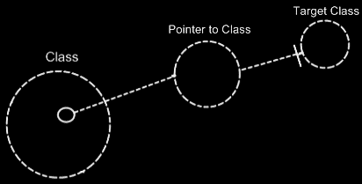

This is mostly applied, to allow a class to make a sub-object’s class *adjustable*.

It is important to consider, that everything inside a pointer is really part of the* *target class*, but* a pointer itself is usable individually, independent from the* target class.

To make a relation to a pointer dual, you* have to give the* target class a relation back to the* first class.

The* relation back can* be displayed in both symbols, that represent the* target class:

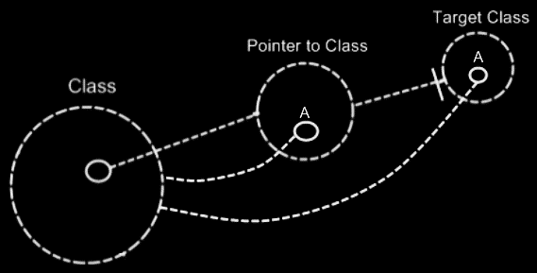

The* two unary relations between **Class** and **Pointer to Class** melt together to a single dual relation. But* the* unary relation from the* **Target Class** to the* **Class** stays unary, because* **Class** does not* directly relate to **Target Class**:

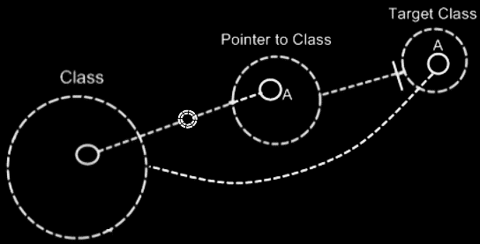

The* notation for a dual relation was covered by the* article *Relations in a Diagram*.

So only **Class** and **Pointer to Class** get a dual relation to eachother.

**Target Class** keeps a unary relation to **Class**. Funny enough, that unary relation is part of the* dual relation between **Class** and **Pointer to Class**. The* dual relation actually consists of:

- **Class** relates to **Pointer to Class**

- **Target Class** relates back to **Class**

The* connection between **Target Class** and **Class** is already implied by the* connection between **Pointer to Class** and **Class**. You*’re allowed to leave out of the* diagram then*:

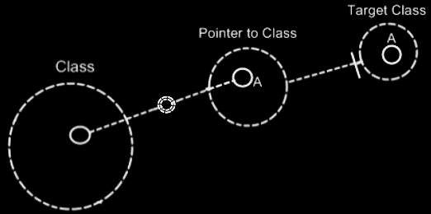

**Target Class** and **Class** are already implicitly related to eachother through the* pointer to the* target class.

In all the* diagrams above, that display the* backward relation, the* sub-symbols of **Pointer to Class** and **Target Class** were given a name: **A**. This was done, because* there was no line in the* diagram to indicate that they were the* same sub-object. Officially, when* symbols share an aspect, in that they are equal in object, class, interface or definition, they should be tied together with a line. Officially an object line should have been connecting both symbols of **A**:

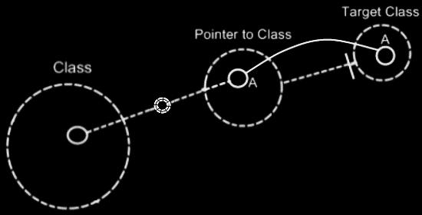

But* similarity in aspect can* also be implied by a *name* and the* *connection between parents*. This kind of implicit connection is explained in the* article *Automatic Containment*.

The* only point to implicit connection through parent is to make the* diagram clearer.

### Relation Synchronization

In a dual relation between classes, one class relates to another and the* other class relates back to the* first class.

But* that is not* enough to establish a full relation.

An object of one class can* refer to an arbitrary object of another class, which then* refers back to an arbitrary object of the* first class again, but* not* necessarily the* object we started with.

To see to it one object relating to another always makes the* other object relate back to the* first object again, you* have to keep the* two counterparts of the* relation synchronized. When* you* make a change to a sub-object’s target, the* other side of the* relation also needs to be updated. This is called *relation synchronization*. Relation synchronization makes something between two objects melt together to one relation. Only when* the* two unary relations are synchronized, then* it is a full dual relation between classes.

If* two unary relations are not* synchronized, then* they are just two separate unary relations, that have nothing to do with eachother.

A complete dual relation consists of three parts:

- one class has a sub-object of another class

- the* other class has a sub-object of the* first class

- the* two unary relations are synchronized

When* you* create a relation, you* are adding those three elements. In the* new computer language you* are still able to create just a unary relation. In a programming environment you* should be able to automatically turn a unary relation to a dual relation. In a programming environment you* should be able to turn two already defined unary relations into a single dual relation.

Relation synchronization is not* present in the* class structure. Relation synchronization happens between *objects*.

As explained in the* article *Relations Between Objects*, any object, that as a relation to another object, gives the* other object one relation back to the* first object. In other words: one reference inside an object is tied to one reference inside another object.

It doesn’t matter if* any of the* two object references resides in a list or not*. When* you* let one of the* object references link to another object, then* the* link from the* old counterpart to the* object should be broken and a link from the* new counterpart to the* object should be established. The* object synchronizes the* old counterpart *out*, and it synchronizes the* new counterpart *in*.

Relation synchronization means ensuring the* integrity between the* two counterparts of a relation. When* you* assign a **Lid** to a **Jar**, the* **Jar** is also assigned to the* **Lid**. So whenever a **Jar** changes its **Lid**, the* original **Lid**’s reference to the* **Jar** is annulled, and the* new **Lid** get a reference to its new **Jar**. This actually explains synchronization between **1 🡪 1** related objects. Synchronization happens when* assigning a related item. When* assigning a related item, the* related item gets a reference back to the* first item.

Relation synchronization happens when* you* assign a related object. When* you* assign **Lid . Jar**, then* synchronizing the* relationship, consists of, in turn, assigning **Jar . Lid**.

For every relation type it works in a different way.

There are three relation types:

**1 🡨🡪 1**

**1 🡨🡪 n**

**n 🡨🡪 n**

But* synchronization is managed separately for each end of the* relation, so synchronization is managed in the* following four of ways:

**1 🡪 1 synchronization**

**1 🡪 n synchronization**

**n 🡪 1 synchronization**

**n 🡪 n synchronization**

#### Synchronization Types

There are four synchronization types:

**1 🡪 1 synchronization**

**1 🡪 n synchronization**

**n 🡪 1 synchronization**

**n 🡪 n synchronization**

Every synchronization type follows a slightly different procedure, to make sure that on assignment of one relation counterpart, the* other relation counterpart goes along with it.

#### 1 🡪 1 Synchronization

**1 🡪 1** synchronization is quite easy. In a **Jar 🡪** **Lid** relation, when* assigning **Lid . Jar**, The* old **Jar . Lid** is set to **Nothing**, while the* new **Jar . Lid** is set to **This**.

#### Risk of infinite loop 1 🡪 1

When* a relation is synchronized, you* may have a risk to an infinite loop.

When* you* assign **Jar** to **Lid**, then* **Lid** is assigned to **Jar**, upon which **Jar** is assigned to **Lid** again, and so on. Fortunately, when* a **Jar** is assigned a **Lid** it already has, the* whole assignment is not* executed. So it only goes as far as: **Jar** is assigned to **Lid**, upon which **Lid** is assigned to **Jar** again, upon which **Jar** is assigned to **Lid** again, but* **Jar** already had that **Lid**, so that assignment is never executed.

#### 1 🡪 n Synchronization

In a **1 🡪 n** relation between **Parents** and **Children**, every time you* assign a **Child** to a **Parent**, **Child . Parent** is overwritten. The* old **Child** is assigned **Nothing** as the* **Parent**, and the* new **Child** is assigned its new **Parent**.

Also, the* original **Child**’s **ID In Parent** is yielded over to the* new **Child. The\*** original **Child**’s **ID In Parent** is reset.

There used to be a misunderstanding, that one **Parent** could* reference the* same **Child** multiple times. But* that idea was abolished, because* when* a **Parent** relates to a **Child** twice, the* **Child** has to relate back to the* **Parent** twice. A **Child** can* only have one **Parent**, so it can* never relate back to the* same **Parent** twice. Something like that would* require an **n 🡪 n** relation, for the* **Child** to be able to hold multiple references to the* same **Parent**.

#### Risk of infinite loop 1 🡪 n

Infinite loops for **n 🡪 1** synchronization the* are prevented the* same way as for **1 🡪 1** synchronization. When* you* assign a **Parent** to a **Child**, The* **Child** is added to the* **Parent**, upon which the* **Parent** is again assigned to the* **Child**. But* the* **Child** already had that **Parent**, so the* assignment is never executed. So that prevents an infinite loop there.

#### n 🡪 1 Synchronization

In a **Child n 🡪 1 Parent** relation, when* you* change **Child . Parent**, the* **Child** is removed from its original **Parent** and added to the* new **Parent**. So you* can* never have the* same **Child** in several **Parents**.

A **Child** can* not* appear multiple times in the* same **Parent**, because* that, in turn, should give a **Child** multiple references back to the* **Parent**, but* a **Child** holds only one reference to a **Parent**.

#### Risk of infinite loop n 🡪 1

When* a **1 🡪 n** relation is synchronized, you* may have a risk to an infinite loop. When* you* add a **Child** to a **Parent**, then* the* **Parent** is assigned to the* **Child**, upon which the* **Child** is added to the* **Parent** *again*.

An earlier solution proposed for this, is that in synchronizing the* relation, you* never boldly **Add** the* **Child** to the* **Parent**, but* you* execute a **Find Or Add**, which prevents the* **Child** from being added again, when* it is already in the* **Parent**’s list. This would* have worked, but* n 🡪 n synchronization already required a different solution, that will be more efficient for n 🡪 1 synchronization as well.

When* you* assign an item to a list for synchronization purposes, no synchronization is to be executed on the* other side again.

You*’d have to call a special **List Item Set** procedure, accessible only to the* related class, that simply won’t synchonize back again.

#### n 🡪 n Synchronization

One *related item* in one object always creates *one related item* inside the* other object.

Two items, related to eachother in an **n 🡪 n** relation, are always connected to eachother, by connecting two specific list positions to eachother.

In **n 🡪 n** synchronization, **Object A**’s reference to **Object B** will be replaced by a reference to **Object C**. When* **Object B** is removed from **Object A**’s list, then* **Object A** is also be removed from **Object B**’s list. After that, **Object A** is added to **Object C**’s list.

An item in one list is aware of its position in the* other list. That makes it easy for an item in one list, to remove itself from the* other list.

#### Risk of inifinite loop n 🡪 n

But* when* you* add **Object A** to **Object C**’s list of related items, then* **Object C** will try to add itself to **Object A**’s list of related items, upon which **Object A** will add itself to the* list of **Object C** again. An infinite loop should be prevented here.

When* synchronizing the* relation between two objects in an **n 🡪 n** relation, you* will add a position to the* list of the* referrer, and next assign an item to this position.

When* you* assign an item to a list for synchronization purposes, no synchronization is to be executed on the* other side again.

You*’d have to call a special **List Item Set** procedure, accessible only to the* related class, that simply won’t synchonize back again.

Another solution opted at first, was to execute a **Find Or Add** for synchronization, instead of executing an normal **Add** command. That would* prevent a related item from being added and added again. But* then* you* have the* problem: maybe the* same item *should* be added twice to the* list, because* one item can* relate to another item multiple times, which also requires the* other item to relate back to the* first item multiple times. For each reference to an item, the* item must have a reference back to the* referrer.

So the* new option is better: you* have a special **List Item Set** procedure, possibly called by a special **Add** procedure, used solely for relation synchronization, that won’t synchronize *back* again.

#### The* abolished multiplicity of x

Earlier I had invented a multiplicity of **x**, which is plural, but* then* a fixed set of items, for instance three items. But* **x** can* be replaced by three separate **🡪 1** relations. **X** was abolished in particular, because* it would* cause a lot of unpredictable behavior when* trying to synchronize the* two relation counterparts, especially in **n/x 🡪 n/x** synchronization.

#### Confusions about relation sychronization

There used to be two points at which there was confusion about the* workings of relation synchronization.

##### Confusion 1

What can* be confusing is that, when* a **1 🡪 n** relation is synchronized, it can* never be used as an **n 🡪 n** relation. In the* relation **Parent 1 🡪 n Child**, every time you* add a **Child** to a **Parent**, **Child . Parent** is overwritten. When* you* change **Child  .  Parent**, the* **Child** is removed from its original **Parent** and added to the* new **Parent**. So you* can* never have the* same **Child** in several **Parents**. If* you* want to use multiple **Parents**, you* can*’t.

It is often easier to define something in **1 🡪 n** relations, without thinking about it, that the* backward relation might be **🡪 n** too. But* when* a relation is synchronized, the* system falls apart when* a **1 🡪 n** is actually intended as **n 🡪 n** and you*’re trying to *use* it that way.

This can* be misconceived as an error in the* new computer language, or an inability of it, while it’s really just a wrongly defined relation.

So then* it becomes really important to define the* exact relation type of something, even when* it’s more difficult.

If* you* do want to use the* **1 🡪 n** relation as an **n 🡪 n** relation, you* should change the* relation type, but* you* could* also choose to split the* dual relation into two unsynchronized unary relations. However, you* will be loosing out on functionality and loosing integrity and coherence of the* system.

A system in which all relations are dual and given the* correct relation type, functions in perfect harmony and everything is logical, correct and solid.

##### Confusion 2

Synchronization could* cause confusion in older versions of the* computer language, where you* have two dual relations to the* same class, that are given the* same **Item Object Name**. In that case, one relation’s counterpart synchronizing back to the* related object could* affect the* other relation. By default it is not* allowed to have one class **A** being **1 🡪** related to multiple classes, in which **A** has the* same **Item Object Name**. That is only allowed if* the* other relations are made unary, and not* dual, or if* *melding* is enabled. *Melding* is a topic, which makes it possible for multiple relation classes or for instance *progressed objects (*article *Progression)*, to be referenced as a single related item, but* it has to be stated explicitly that this is the* intention. See the* article *Melding*.

#### Diagram Notation

There isn’t really a display of relation synchronization in a diagram. You* just know, that when* a dual relation is expressed, the* relation will be synchronized.

The* procedures of relation synchronization are part of the* system interface of symbols. System interfaces are the* inner workings of symbols. The* procedures of relation synchronization can* be expressed in the* diagram, if* the* system interfaces of the* symbols are displayed. See the* article *System Interface*.

This article shows diagrams to demonstrates the* difference between *not\** synchronizing two unary relations and *synchronizing* two unary relations.

Two unary relations will not* be synchronized to eachother. An object of Class A can* refer to an arbitrary object of Class B, which refers to an arbitrary object of Class A again.

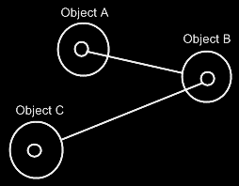

It doesn’t make the* two objects refer to eachother. It just makes the* two objects refer to an arbitrary object of the* other class, but* not* necessarily to eachother.

For this, relation synchronization is applied, so that the* first object and the* second object always refer to eachother.

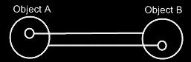

When* the* two following unary relations are synchronized,



then* the* two class lines merge together, to form the* picture below:



Relations between individual objects also turn from this:



Into this:



### Relation Direction

When* all relations are bidirectional, a side-effect might be that everything might end up at the* same level hierarchically, since all the* relationships are mutual.

That might bump with the* containment structures that might look nice in Circle notation.

A proposed solution might be to specify a direction to these relations, so that the* 'inferior' part of the* relationship might be put at a lower level of containment, restoring the* use of a containment structure. Perhaps a 1 to n relations might already imply direction: parent on top, children below.

This may only be a problem, if* the* containment structure would* have to be figured out by the* system on its own.

Another solution might be that a programmer can* pick the* containment level, so then* maybe it is not* really a problem and relation direction would* be implied by the* containment levels picked by a programmer.

## Loose Ideas

### Loose Ideas about Referrers

Taken out of the* Referrers article:

<Compared to giving a number class a related list for every class that uses integers>

A number class could*, however, choose to support a single list of all referrers. Then* a number object will have only one related list. Numbers may be used by many classes, but* an individual number object, is never used much. It is not* a lot of data to register inside an integer object, which objects refer to that particular number.

JJ

Referrers,

2008-08-10

The* Referrers concept needs to be redone.

Consider the* system interface and make sure

you* can* register referrers in a reference,

as well as referrers to an object,

and consider whether you* want the* referrers

list to point to references or the* the* parents of the* references.

The* article Referrers in a Diagram, Class Referrers in a Diagramand Command Definition Referrers in a Diagram are involved.

I was looking at the* Refferes diagrams. It’s not* correct. The* referrers list registers the* parents of the* references. I’m thinking now: they should register the* references themselves. I must have been that I was unaware of the* workings of the* system interface back then*…

JJ

Referrers,

2008-08-28

Referrers has to be redone. It has to become a list of related items and related list items, that they are inside their parents.

Redoing Referrers was postponed in the* project Work Out Basic Command Articles, because* it involves too much other material, that takes too much time to go into.

Referrers is mainly part of Relations.

You* are probably going to have to read over the* whole Relations article group.

The* following articles may have to be redone, when* redoing Referrers:

- Referrers

- Referrers in a Diagram

- Class Referrers

- Class Referrers in a Diagram

- Referrers Versus Related Objects

- Command Object Referrers

- Command Object Referrers in a Diagram

- Command Definition Referrers

- Command Definition Referrers in a Diagram

JJ

Referrers,

2008-08-28

The* referrers articles are not* finished, because* referrers needs to be reconsidered later, and it involves much different material, that takes time to go into.

- I hate it, that I could* not* finish the* referrers articles.

- But* it is too much to go into just like that.

- I have to accept that the* produced article group will contaiin two subjects, that are not* finished.

JJ

Referrers,

Referenties naar een copy functie wil je

ook niet in de in de copy command definitie zelf bijhouden.

Maar je zou wel de mogelijkheid willen hebben om te querien

welke kopieeracties er binnen een bepaald systeem zijn.

Je kunt altijd een ruwe sequentiele zoek-query uitvoeren op

een subsysteem.

Maar je wilt het misschien ook centraal bijhouden. Dan

zou je een filter index moeten kunnen maken,

maar een filter index gezet op een elders gedefinieerde

method of class.

Ik heb er toch best moeite mee, dat je

in een stuk diagram niet ziet wat er allemaal naar

een bepaald object verwijst, maar alleen waarnaar

de objecten in de diagram verwijzen.

O, wacht, dat gebeurt voor objecten wel, omdat

de gerelateerde objecten als sub objecten worden getoond.

Heen en weer relaties tussen objecten in principe gelijkwaardig.

Maar bij methods is het anders. Die hebben altijd een richting,

en de relatie terug is echt de backwards verwijzing.

Het is zeg maar een kwestie van 'belachelijk om allemaal bij te houden'.

Alleen soms wil je voor een definitie, die zijn referrers niet bijhoudt,

toch referrers bijhouden.

Eigenlijk moet dan een systeem de referrers naar een definitie van een

ander systeem bij kunnen houden.

Je maakt bij methods eigenlijk ook relaties tussen method definitions aan.

Die zouden dan ook referrers bij kunnen houden, en een gesynchroniseerde

relatie aan kunnen gaan.

JJ

### Loose Ideas about the* Relations Section

#### ± 2004

The* main unit in a relational structure is the* *class*. There is a list of *classes*.

The* classes are tied together with *relations*. One class is tied to another.

The* main object that defines a relational structure is the* Structure object. The* Structure object contains a Classes collection and a Relations collection. If* you* want to add a class, you* do that in the* Classes collection. If* you* want to add a relation, you* do that in the* Relations collection.

The* Classes collection contains objects of class Class.

The* Relations collection contains objects of class Relation.

Every Class has an Attributes collection. A Person Class, for instance, could* have a Name Attribute and an EmailAddress Attribute and more attributes such as Street, HouseNumber, ZipCode, etcetera. A Class also contains a RelatedClasses collection, which reflects all of the* class’s related classes. You* can*’t add RelatedClasses to this collection. You* have to define relations in the* Structure.Relations collection and they will be *reflected* in the* Class.RelatedClasses collection. Other members of the* Class class are explained in other sections, covering different concepts. However, all members are briefly explained in a sub section below.

A **Relation** consists of two **RelationClasses**. It contains two **RelationClass** objects that define the* two classes of the* relation and how they relate to one another.

A **Relation** also defines whether the* relation is **Dual** or **Unary**, by the* **Boolean** **Dual** member. If* a **Relation** is **Dual**, then* both classes are aware of eachother and refer to one another. If* a **Relation** is **Unary** then* only **RelationClassA** is aware of **RelationClassB** and refers to it, but* **RelationClassB** is unaware of **RelationClassA** and doesn’t refer to it.

Even though a **Dual** relation would* seem to make **RelationClassA** and **RelationClassB** equal opponents, **RelationClassB** in many cases is the* inferior one. For instance, in writing XML files, **RelationClassB** is seen as contained in **RelationClassA** and not* the* other way around. In that case *direction* of the* relation does matter. However, still in many cases **RelationClassA** and **RelationClassB** are technically equal opponents. When* you* keep in mind which **RelationClass** is inferior and which one is superior, things like XML writing go well automatically. If* you* are sloppy with choosing if* something is **RelationClassA** or **RelationClassB**, you* could* get trouble that makes you* obliged to switch the* two relation classes within the* relation, but* usually you* won’t notice anything going wrong. So relax, but* beware.

The* two **RelationClass** objects define the* relation furtherly.

The* member **Class** of **RelationClass** is very important to set, and it defines which class makes part of the* relation. Define the* **Class** in both **RelationClasses** of the* **Relation** and you*’ve made a relation between the* two classes.

A very important member of a **RelationClass** is the* **AbstractNumber**. This defines whether a relation class is **1**, **x** or **n**. If* you* define the* **AbstractNumber** for both of the* two relation classes, you* can* for instance make a 1🡨🡪n relation between the* two classes or a x🡨🡪n relation or whatever. **AbstractNumber** is **1** by default.

To define the* quantity of x, you* set **ExactNumber**. For instance, in a   
**Line n🡨🡪2 Point** relation, you* define for the* **Point** **RelationClass** that its **AbstractNumber = x** and its **ExactNumber = 2**.

Two other important members of a **RelationClass** are **CreateObjects** and **EnsureSubObjects**. **CreateObjects** is by default **True**, exceptions not* regarded. **CreateObjects** says that when* a new position is created within the* related list, an object is instantly *created* in that position (See *Objects and Object Positions*). In many cases you* want that to happen. Sometimes you* don’t want objects to be created, because* you*’d want to assign an object to that position yourself. Then* you* set **CreateObjects** to **False**. Furtherly, **EnsureObjects** will see to it that you* can*’t assign **Nothing** to the* object position. It is **True** by default, but* can* be set to **False**. For more information see the* sections *Create Objects* and *Ensure Objects*.

And then* there’s another member of **RelationClass** that is important to mention. And that is **ListType**. **ListType** is usually set to **NormalListType**, but* can* also be set to **ReferenceCountedListType**, **RegistrationListType**, **SharedListType** or **SelectionListType**. The* list then* gets very special behavior. For more information see the* *Specialized Lists* section. Although I don’t explain them here very thoroughly, **ListType** does mean a lot for the* general structure of the* system.

You* can* see that inside a **RelationClass** object, much more is defined than just the* **Class**. That’s why **RelationClass** is a separate class. Many times I will speak of a relation class, and you* shouldn’t confuse it with just a class then*, because* it will be defining a class as it is in the* context of a relation.

The* elements as I’ve described them in this section, form the* following structure of Classes, Attributes and Relations.

Structure

|

|-- Classes

| |

| |-- Class ()

| |

| |-- Attributes

| | |

| | |-- Attribute ()

| |

| |-- RelatedClasses

| |

| |-- RelationClass ()

|

|-- Relations

|

|-- Relation ()

|

|-- Dual

|

|-- RelationClassA and RelationClassB

|

|-- Class

|-- AbstractNumber

|-- ExactNumber

|-- CreateObjects

|-- EnsureObjects

|-- ListType

Every other concept of J Data is hung up on this main structure of **Classes**, **Attributes** and **Relations**.

For instace, the* physical appearance in the* user interface of a list defined in a **RelationClass** with **AbstractNumber = n**, is defined inside that **RelationClass** object. The* whole appearance of a **List Control** is defined inside a **RelationClass**. That is an example of how the* user interface is defined right inside the* general structure above. The* same way *all* of the* application’s features are defined in the* context of the* relational structure of **Classes**, **Attributes** and **Relations**.

### Loose Ideas about Dual & Unary

Relations,

New thing: what I should consider in the* future, is that a relation counterpart can* be completely derived from the* other relation counterpart. Therefore, you* might make a relation dual, so the* counterpart usable, but* not* STORE it, but* derived it somehow. That way you* can* use all relation counterparts, just not* store the* ridiculously large ones. > No, because* then* you*’d have to scan the* whole internet for referrers.

JJ

### Loose Ideas about Relation to a Pointer

Relations,

Relations to Pointers,

2008-09-25

Pointers (references to related objects)

A relation between a *pointer to an object* and a *command*. The* pointer is a totally different entity, than the* object itself.

> 2008-10-01 I’d think, that this will add related objects to the* system interface, so related objects to a related item system object, instead of related objects to the* target object of the* related item system object.  
This is a relations issue: relations to pointers in particuler.

I will need to look at *System Objects* to see what a pointer actually was: it was a relation to a related item, instead of a relation to an object independent of any other container.

JJ

### Loose Ideas about Relations in General

*The* texts below are loose ideas yet to be turned into good documentation.*

References,

2008-11-05

It is important to exactly see

which objects can* be accessed through an object.

You* should see access connectors for them.

It is also very important that you* can* exactly see

which object access something.

You* have too much the* ability to not* register

which objects actually access something.

Perhaps in practice it is not* so bad to impose registering

dependencies always. Perhaps practically the* consequences

are overviewable.

The* negatives about not* seeing ALL referrers, but* only some,

or optionally are BAD. Because* not* seeing the* connections between

all things create a lot of problems in software systems today.

Perhaps most problems with software systems today have to do

with not* knowing what exactly makes use of what.

But* how about commonly used classes, such as integer.

Integer objects all around can* store a link to the* integer class

on the* computer language site. But* the* integer class

on the* computer language site can* not* register all objects

around the* globe of class integer.

Or perhaps consequences of many many references to the* same

class can* be MADE overviewable.

Perhaps you* can* make intermediate references to class integer

on your local site or local module. Then* the* references to class integer

on that site, reference the* local reference to class integer.

The* references to class integer on a site are registered in

the* local site's shadow of class integer.

And in class integer on the* computer language site only the* shadow

itself is registeren.

Perhaps you* can* enforce such a pattern.

It is always a problem with classes widely used.

Any class could* potentially be widely used.

You* could* set reference quota, though, to protect your site.

But* class integer should be used billions and billions of times.

Perhaps to protect your site, you* make a reference quata,

or you* enforce shadowing.

In a shadow situation, I'd like to also see how many referrers

a shadow of class integer has. But* you* can* do that.

Site computer language has class integer, which registers all

sites using class integer, and those registrations consist of

the* registration of a shadow reference of class integer,

and the* shadow reference of class integer returns the* references

of the* shadow again, but* those references are stored on the*

client site, not* on the* computer language site.

You* still register all integers, but* the* registration is spread over

multiple sites, so the* costs are spread and everybody pays

a reasonable amount of storage cost.

But* could* this pattern be misused?

What if* a new internet protocol allows many many more sites,

and somebody thinks it is cool to create 1,000,000 virtual sites,

for some purpose and each site shadows class integer.

Then* you* have 1,000,000 more registrations in class integer.

That's where quota's come in.

But* that can* also be abused. An attack could* use up the* quota,

and new shadows to integer can* not* be made anymore.

Existing sites, that use class integer still work,

but* nobody can* program a new site of class integer then*.

But* there is a difference between in good practice, and in bad practice.

You* have to ask yourself: how can* we make it practically work when* we

are all behaving ourselves. Some things do not* work practically even if*

we do behave ourselves. That's one area of problems to work on.

It is another area of problems where well behaved practice works,

but* bad behavior overthrows the* system.

That last part we call attacks, virusses, threats, etcetera.

That area of problems should be adressed differently.

It is a principle, that good practice should be facilitated,

and bad behavior should not* compromise how clear you* can*

organize your system, so should not* compromise your freedom.

Bad behavior should be adressed separately in the* background.

Enough for now.

JJ

Taken out of Interfaces Articles on 2010-05-07:

Preventing class’s extension with commands:

A class can* prevent itself from getting further extended with commands.

For instance, you* don’t want the* class Integer to be extended with any command that uses an integer. It is a question of it being rediculous to maintain a list of all commands that uses integers. Don’t prevent a class from being extended with commands, just because* you* think it makes your interfaces more reliable. Class Integer can* also just make it a *default*, that it doesn’t get further extended with commands. Some commands that use Integer, you* might indeed want to see added to class integer, but* you* need to actively choose that then*. If* parameters don’t extend a class with a commands, these parameters are only shown as parameters, and not* as commands inside a class definition.

> 2008-09-06 This is actually a non-dual relation.

This is basically the* same issue as covered in the* section Dual & Unary, which explains, when* it is ridiculous to maintain a backward relationship. For instance: relationships from class Integer back to any class, that uses an integer are rediculous to maintain as well.

And if* changes to the* class are ventilated to all the* objects this happens with the* help of events, but* usually you*’ll just use versioning to use an unchanging production version of a class.

a class can* *access control* the* fact whether dual relations can* be established to it.

I think, that a dual relation has a source site. One end of the* relation has authored the* relation, the* other relation just complied.

Actually, this could* happen dually.

JJ

Backwards relation alternative: Site usage

2010-05-03

For ‘ridiculous to maintain’ you* could* also go with this approach: make the* small thing, like Integer always referenced in a qualified way through the* site and maintain a unique list of source sites. That would* at least give you* an idea of how many sites are used and if* any sites still use it.

JJ

Relationships,

2008-11

The* roles that symbols get when* connecting them with lines.

JJ